**FLIP-FLOPS**

**FLIP-FLOP:**

A flip-flop is a [bistable multivibrator](https://testbook.com/electrical-engineering/bistable-multivibrator) used in digital electronics to store a single bit of binary data, either 0 or 1. It is essentially a memory device that retains its state until a control signal triggers a change. Flip-flops are fundamental components used in [sequential logic circuits](https://testbook.com/electrical-engineering/sequential-circuit), where they act as basic storage elements. To define flip flop in digital electronics, it can be stated as a circuit that has two stable states and can store information based on input signals. The flip flop definition in digital electronics revolves around the control of state changes and data storage using clock pulses or triggering signals.

Flip-flops operate by reacting to either the rising or falling edge of a clock pulse, and they are a significant part of digital electronics for storing information over time. This helps in designing systems where specific sequences of data are required.

**Types of Flip-Flops**

* S-R Flip-Flop
* J-K Flip-Flop
* D Flip-Flop
* T Flip-Flop

1. **S-R FLIP-FLOP**

This is the simplest flip-flop circuit. It has a set input (S) and a reset input (R). In this circuit when S is set as active, the output Q would be high and the Q' will be low. If R is set to active then the output Q is low and the Q' is high. Once the outputs are established, the results of the circuit are maintained until S or R get changed, or the power is turned off.

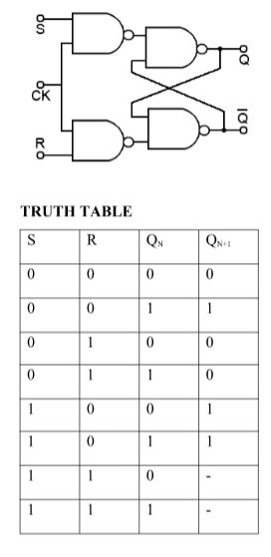



**Working of SR Flip Flop**

The working of a SR Flip Flop is determined by the behaviour of its two inputs, S and R, and how they affect the outputs Q and Q'. Here’s a detailed explanation:

* **Set (S = 1, R = 0):** When the set input is 1 and the reset input is 0, the flip-flop enters the set state, making Q = 1 and Q' = 0.
* **Reset (S = 0, R = 1):**When the reset input is 1 and the set input is 0, the flip-flop enters the reset state, making Q = 0 and Q' = 1.
* **No Change (S = 0, R = 0):** When both inputs are 0, the flip-flop maintains its previous state, meaning that Q and Q' remain unchanged.
* **Invalid State (S = 1, R = 1):**When both inputs are set to 1 simultaneously, the output becomes indeterminate, leading to an invalid or ambiguous state. This is a critical limitation of the basic SR Flip Flop.

**Characteristic Equation of SR Flip-flop:**

Q(t+1) = (Q(t) . R(t)) + S(t)

**Advantages:**

* Simplicity: SR flip-flops are relatively simple to design and implement, requiring fewer components than other flip-flops.
* Low Power Consumption: They typically consume low power, making them suitable for battery-powered devices.
* Bistable Operation: They can maintain a stable state (either set or reset) until a change is triggered, making them useful for memory storage and control systems.

**Disadvantages:**

* Race Condition: A major drawback is the "race condition" or "forbidden state" when both S and R inputs are asserted simultaneously. This leads to unpredictable output behaviour.
* Susceptibility to Glitches: They can be sensitive to glitches or noise on the input signals, potentially causing unwanted state changes.
* Limited Functionality: Compared to other flip-flops (like JK or D), the SR flip-flop has a more limited set of functionalities. For example, it doesn't have a toggle state.

**Applications of SR Flip Flop**

The SR Flip Flop is widely used in various applications in electrical engineering and digital electronics:

* Memory Storage: SR Flip Flops are used in registers and latches to store bits of data.
* Switch Debouncing: They are employed in circuits where mechanical switch bounce needs to be eliminated.
* Control Systems: SR Flip Flops are used in state machines and control circuits where binary decision-making is required.
* Sequential Circuits**:** They form the foundation of more complex circuits like counters and shift registers.

1. **J-K FLIP-FLOP**

The JK Flip Flop is a universal[flip-flop](https://testbook.com/electrical-engineering/what-is-flip-flop-in-digital-electronics), named after Jack Kilby, one of its inventors. It is an improvement over the SR Flip Flop, designed to eliminate the indeterminate state encountered when both inputs are high. The JK Flip Flop full form stands for Jack Kilby Flip Flop, emphasizing its contribution to modern digital systems. The JK Flip Flop definition can be summarized as a bistable multivibrator with two inputs—J (Set) and K (Reset)—and two outputs—Q and Q'. It operates in such a way that it not only stores a single bit of data but also toggles the output when both inputs are high, thus overcoming the limitations of the SR flipflop.

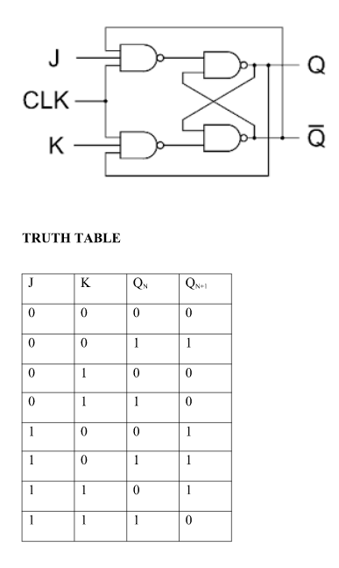



**Working of JK Flipflop**

The Characteristics of a JK Flip Flop can be understood by analysing how the inputs J and K affect the output states:

* J = 1, K = 0: This condition sets the flip-flop, making Q = 1 and Q' = 0.
* J = 0, K = 1: This condition resets the flip-flop, making Q = 0 and Q' = 1.
* J = 0, K = 0: When both inputs are 0, the flip-flop retains its previous state, whether it's set or reset.
* J = 1, K = 1: In this case, the flip-flop toggles, meaning if Q = 1, it changes to Q = 0, and vice versa.

**Characteristic Equation**

The characteristic equation of the JK flip-flop is:

Q(t+1) = (J(t) . Q`(t)) + (K(t) . Q(t))

**Race Around Condition in J-K Flip Flop**

When the J and K both are set to 1, the input remains high for a longer duration of time, then the output keeps on toggling. Toggle means that switching in the output instantly i.e. Q=0, Q’=1 will immediately change to Q=1 and Q’=0 and this continuation keeps on changing. This change in output leads to race around condition.

The master-slave JK Flip Flop is a more advanced configuration of the basic JK Flip Flop. It involves two JK Flip Flops connected in series, where the first flip-flop (master) is triggered on the rising edge of the clock pulse, and the second flip-flop (slave) is triggered on the falling edge. This arrangement solves issues like the race around condition in JK Flip Flop, ensuring that the output remains stable and free from glitches. The master-slave JK Flip Flop operates in such a way that the inputs are locked during the clock pulse transition, preventing unintended toggling.

**Advantages:**

* Toggling Functionality: When both J and K inputs are high, the JK flip-flop toggles its output, making it useful in counters and other sequential logic circuits.
* No Invalid States: Unlike the SR flip-flop, a JK flip-flop doesn't have an invalid state when both inputs are high, leading to greater reliability.
* Versatility: The JK flip-flop can perform set, reset, and toggle operations, making it flexible for various applications.
* Edge-Triggered Configuration: The master-slave JK flip-flop allows for edge-triggered operations, which helps eliminate race conditions.
* Frequency Division: The JK flip-flop can be used for frequency division by two, which is helpful in clock division circuits.

**Disadvantages:**

* Race Conditions: At higher clock speeds, JK flip-flops can experience race conditions, leading to unstable outputs.
* Increased Complexity: JK flip-flops are more complex than some other flip-flop types, requiring more gates and connections.
* Limited Scalability: Scaling up JK flip-flops in complex digital systems can increase complexity and the potential for errors.
* Propagation Delay: The JK flip-flop has a propagation delay, which can cause timing issues in systems with tight timing constraints.

**Applications of JK Flip Flop**

The JK Flip Flop finds widespread application in various digital electronics systems:

* Counters: Its toggling capability makes it the perfect candidate for use in binary and decade counters.
* Shift Registers: It is used in sequential circuits where data needs to be shifted between flip-flops, as in shift registers.
* Memory Devices: It serves as a basic memory element in registers and other storage devices.
* State Machines: JK Flip Flops are used in finite state machines, where the system needs to toggle between states based on inputs.
* Clock Dividers**:**They can be used to divide the frequency of clock pulses in clocked circuits.

1. **D FLIP-FLOP**

In a D flip-flop, the output can only be changed at positive or negative clock transitions, and when the inputs changed at other times, the output will remain unaffected. The D flip-flops are generally used for shift-registers and counters. The change in output state of D flip-flop depends upon the active transition of clock. The output (Q) is same as input and changes only at active transition of clock.

The D flip flop in digital electronics, also known as the data or delay flip-flop, ensures that the output follows the input with every clock pulse. It has a single data input, which simplifies the design and is widely used in registers and memory units.

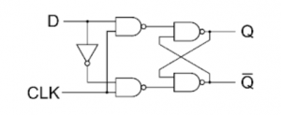

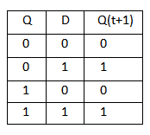

**Characteristic Equation**

The characteristic equation of the D flip-flop is:

Q(t+1) = D(t)

**Advantages:**

* Simplicity: A single data input (D) simplifies the design and reduces the number of required connections, which can be beneficial in complex circuits.
* No Invalid States: Unlike SR flip-flops, D flip-flops prevent invalid output states, ensuring more predictable behaviour.
* Ease of Use: The single data input makes them easier to understand and implement in various digital circuits.
* Data Storage: D flip-flops are fundamental for storing data and maintaining it until the next clock signal.

**Disadvantages**

* Delays: D flip-flops introduce a delay between the input and output, which can be a concern in high-speed applications.
* Timing Issues: Careful attention must be paid to clock pulse width, data setup, data hold, and reset recovery requirements to ensure proper operation.
* Lack of Built-in Feedback: Unlike JK flip-flops, D flip-flops lack built-in feedback, which can be useful for certain types of counters or state machines.
* No Toggle Function: They do not have a direct toggle function, which may require additional logic for certain applications.

**Applications of D Flip-Flops:**

* Data Storage: D flip-flops can store a single bit of data, making them essential for building memory circuits and registers.
* Synchronization: They are used to synchronize asynchronous signals to a clock signal, ensuring that data is captured reliably.
* Delay Lines: By cascading D flip-flops, a delay of multiple clock cycles can be introduced, useful in digital signal processing.
* Shift Registers: D flip-flops are connected to create shift registers, which are used for serial data transfer and storage in various applications, including serial communication protocols like UART, SPI, and I2C.
* State Machines: D flip-flops are used to implement state machines, which control sequences of events in digital systems, found in applications like control systems and industrial automation.
* Counters: D flip-flops can be used to create binary counters that can count up or down, making them suitable for timers and clock applications.
* Frequency Dividers: By connecting the output of a D flip-flop to its input (feedback), the flip-flop toggles with every two clock pulses, effectively dividing the clock frequency.
* Event Detection: D flip-flops can be used to detect specific events, such as the switching on of a light.
* Embedded Systems: In embedded systems, D flip-flops are used to store control signals, latch sensor inputs, and track the status of digital subsystems within microcontrollers or processors.

1. **T FLIP-FLOP**

The T flip flop in digital electronics toggles the output state with every clock pulse when the input T is high. It is often used in counters and other timing applications. A T flip-flop, or Toggle Flip-flop, is a simplified form of the JK flip-flop, created by connecting the J and K inputs together. It features a single input terminal along with a clock input. Known for its ability to toggle the output state, T flip-flops are commonly used in counters due to this toggling function.

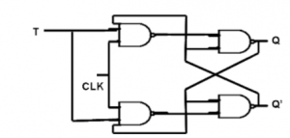

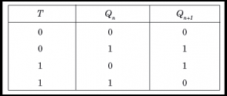

**Characteristic Equation**

The characteristic equation of the D flip-flop is:

Q(t+1) = Q(t) ^ T(t)

**Advantages:**

* Simplicity: T flip-flops are relatively simple to design and understand, making them easy to implement in digital circuits.
* Versatility: They can be used in various applications, including frequency division and counter circuits.
* Edge-Triggered: T flip-flops are edge-triggered, which allows for precise control of state changes at the rising or falling edge of the clock signal.
* Frequency Division: They can efficiently divide the frequency of a clock signal by two.
* Counters: Their toggling behaviour makes them well-suited for constructing binary counters.

**Disadvantages:**

* Limited Functionality: T flip-flops only have one input (the "T" or toggle input) and cannot perform complex operations like addition or multiplication.
* Dependency on Previous State: The present state of a T flip-flop can only be determined if the previous state is known.
* Complex Sequences: For handling more intricate sequences of operations, other flip-flop types (like JK or D flip-flops) might be more suitable.
* Availability: Standalone T flip-flop integrated circuits are not commonly available. They are often implemented using other flip-flops like JK or D flip-flops.

**Applications of D Flip-Flops:**

* Counters: T flip-flops are foundational in building binary counters, where they toggle their output state on each clock pulse, allowing for counting events or measuring frequency.
* Frequency Division: By toggling on each clock pulse, a T flip-flop effectively divides the input frequency by two. Cascading multiple flip-flops allows for further frequency division, useful in timing circuits.
* Data Storage: T flip-flops can store a single bit of data, making them useful in memory elements and holding data within digital systems.
* Synchronous Logic Circuits: They play a role in synchronous logic systems, ensuring that state transitions are coordinated based on clock signals, improving timing and reliability.
* Shift Registers: T flip-flops contribute to shift registers for bit-level data manipulation, facilitating shifting data left or right on clock pulses, crucial for serial-to-parallel and parallel-to-serial data conversion.

**Summary of Flip Flops:**

|  |  |  |
| --- | --- | --- |
| **Flip-Flop** | **Functionality** | **Applications** |
| SR Flip-Flop | Set/Reset | Simple storage |
| JK Flip-Flop | Toggling | Counters, control circuits |
| D Flip-Flop | Data storage | Registers, memory units |
| T Flip-Flop | Toggling | Frequency dividers, counters |

**Advantages of Flip Flop:**

The main advantages of using flip-flops are:

* Data Storage: Flips-flops can store one bit of data (0 or 1) and retain it reliably until an external operation changes the state.
* Clocked Operation: Their synchronous operation based on clock pulses makes them suitable for sequencing operations.
* Area Efficient Memory Storage: Flip-flops provide the basic storage needed for counters, registers, memory etc.
* Uniformity: Consistent structure and functional operation across different types of flip-flops.

**Applications of Flip-Flops**

Flip-flops are used in a wide range of applications in digital systems. Below are the major uses:

* Memory Units: They store individual bits of data in various types of registers.
* Counters: JK and T flip-flops are commonly used in binary counters.
* Shift Registers: D flip-flops are used to move data in shift registers, which are essential in serial communication.
* Frequency Dividers: T flip-flops are used to create frequency-dividing circuits.
* State Machines: Flip-flops are integral to state machine designs, where they store the current state of the machine.

**Difference Between Latch and Flip Flop in Digital Electronics**

Latches and flip-flops are both used to store binary data, but they differ in how they operate.

* Latch: It is a level-triggered device that can change state whenever the input signal is high. It does not require a clock signal for operation, making it asynchronous.
* Flip-Flop: This is an edge-triggered device that only changes state on a clock pulse, making it synchronous.

|  |  |  |
| --- | --- | --- |
| **Aspect** | **Latch** | **Flip-Flop** |
| Triggering | Level | Edge |
| Clock Required | No | Yes |
| Asynchronous/Synchronous | Asynchronous | Synchronous |
| Complexity | Less Complex | More Complex |